**TOPIC: PHOTOSYNTHESIS IN HIGHER PLANTS AND RESPIRATION IN PLANTS**

**UNIT NO: B-07**

1. Where does water splitting complex is associated with PS II complex is situated

1. Inner side of chloroplast outer membrane 2. Inner side of thylakoid membrane

3. Outer side of thylakoid membrane 4. Inner side of chloroplast inner membrane

1. Which of the following statements is wrong?

1. Usually chloroplasts align themselves along the walls of mesophyll cells, so that they get optimum quantity of incident light

2. Within chloroplast there is a membranous system consisting of grana, stromal lamellae and stroma

3. RuBisCO is the most abundant protein found within a chloroplast

4. In grana CO2 is fixed

1. The membranous system of grana is responsible for

1. Trapping light energy, but not ATP and NADPH2 formation

2. Trapping light energy and also for fixation of CO2

3. For ATP and NADPH2 formation, but not for light trapping

4. For light capturing and also for NADPH2 and ATP formation

1. Water splitting complex is associated with

1. Outer membrane of chloroplast. 2. Inner membrane of chloroplast.

3. Stroma. 4. PS II

1. Light reactions or the Photochemical phase do not include

1. Light absorption 2. Water splitting and oxygen release

3. Production of sugars

4. The formation of high-energy chemical intermediates, ATP and NADPH.

1. Which statement about the light reactions of photosynthesis is false?

1. PS I and PS II are located in stroma of the chloroplast

2. PS I and PS II are linked by e- carriers

3. Chlorophylls have and absorption spectrum with pronounced peaks in red and blue light

4. Protons diffuse through protein channels which are ATPsynthetase molecule

1. Photosystem is composed of

1. Light harvesting complex 2. Reaction center

3. Accessory pigments 4. More than one option is correct

1. 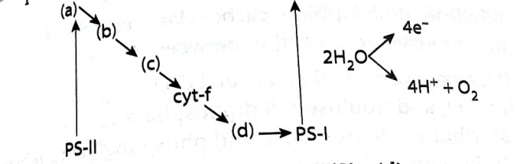In the schematic diagram shown below, which is Plastocyanin

1. (c)

2. (d)

3. (a)

4. (b)

1. 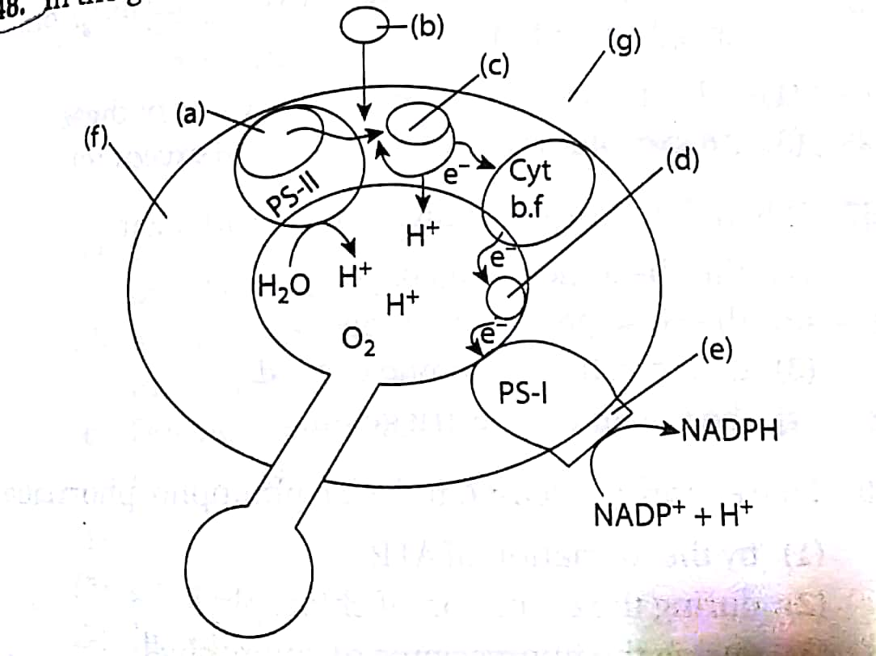In the given ETC in the chloroplast. (a)-(g) represent

1. (a)- Secondary e- receptor; (b)- Hydrogen; (c)-H+;

(d)- PC; (e)-*fd*; (f)- Chloroplast membrane;

(g) intrathylakoid space

2. (a) Primary e- receptor; (b) e- acceptor; (c) H+;

(d) e- acceptor; (e) NADPH; (f) enzyme;

(g) Chloroplast membrane

3. (a) OEC; (b) H+; (c) e- acceptor; (d) PC; (e)*fd*;

(f) chloroplast membrane; (g) matrix

4. (a) Pheophytin; (b) H+; (c) Hydrogen acceptor; (d) e- acceptor; (e) NADP reductase;

(f) thylakoid membrane; (g) stroma

1. In photosystem II, the reaction centre chlorophyll-a absorbs (a) wavelength of red light causing electrons to become excited and jump into an orbit (b) from the atomic nucleus. These electrons are picked up by an electron (c) which passes them to an electron transport system consisting of (d)

1. (a) -703 nm; (b) - farther; (c) -donor; (d)-phytochromes

2. (a)-700 nm; (b) - nearer; (c)- acceptor (d)-cytochromes

3. (a) -683 nm; (b) -nearer; (c) – donor (d)-phytochromes

4. (a)-680 nm; (b) -farther; (c)- acceptor (d) – cytochromes

1. Select the correct match.

1. Site of Calvin cycle - Bundle sheath cells in C3 plants

2. Primary acceptor of carbon in Calvin cycle PEP

3. First stable product of Calvin cycle- 3PGA

4. Site of Calvin cycle in C4 plants - Mesophyll cells

1. In chemiosmotic synthesis of ATP, H+ diffuses through ATP synthetase

1. From the stroma into thylakoid lumen/space 2. From thylakoid space into stroma.

3. From the cytoplasm into stroma. 4. From the periplasmic space to stroma

1. Which of the following is incorrect about cyclic photophosphorylation?

1. Only PS I involved

2. It occurs when only light of wavelength beyond 680 nm is available for excitation.

3. Only synthesis of ATP occurs

4. Synthesis of NADPH +H+ occurs.

1. Which of the following is correct about biosynthetic phase?

1. 14C isotope is used to find out this pathway.

2. Calvin worked on this pathway

3. Melvin Calvin used photosynthetic algae for this pathway 4. All of these

1. Which one of the following statements are correct

a) Light reaction occurs in stroma.

b) Light reaction occurs in grana and ATP+ NADPH2 are formed

c) In stroma dark reaction occurs.

d) Dark reaction is not directly light driven dependent on the products (ATP NADPH2)formed in light reaction

1. All of these 2. None of these 3. All except (a) 4. All except (c)

1. The Z scheme refers to

1. The type of photosynthesis used in plants found in areas with minimal precipitation

2. The pattern of grana within the chloroplasts of photosynthetic plants

3. The carbon fixation process also known Calvin cycle

4. An energy diagram for the transfer of electrons is the light reactions of photosynthesis in plants

1. Which one of the following statemen describes cyclic photophosphorylation?

1. Cyclic photophosphorylation has both P'S I and PSII

2. Cyclic photophosphorylation produces neither ATP nor NADPH + H+

3. During photolysis of water formation of ATP + NADPH + H+ occur

4. Production of NADPH + H' is associated with PS II not PS I

1. During light dependent reactions, light energy is converted to chemical potential energy through the process of chemiosmosis in the chloroplasts. Which of the following statements about this process is false?

a. The electron carriers of phosphorylation are located in the thylakoid.

b. During phosphorylation, the chloroplast stroma becomes more acidic than the interior of thylakoid membrane

c. Protons diffuse through the protein channels which are ATP synthetase molecules

d. ATP is formed from ADP + Pi on the stroma side of the thylakoid in the chloroplast

e. During phosphorylation, water ionises to form H++ 20H-, yielding an e- to PSII.

1. a, b, e 2. Only b 3. c and d 4. Only d

1. In Calvin cycle, which stage requires ATP?

1. Carboxylation only 2. Only regeneration

3. Both carboxylation and reduction 4. Both reduction and regeneration

1. In chemiosmotic hypothesis for energy generation in chloroplast

1. Electron transport carriers set up a proton gradient.

2. A pH gradient drives the hydrolysis of ATP to ADP

3. ATP must be continuously translocated into the chloroplast

4. The electron transport carriers use energy of moving electron in uphill direction to form ATP

1. How many moles of ATP are required to regenerate one mole of RuBP?

1. 1 2. 2 3. 3 4. 4

1. Which one of the following is a correct outline of the main events in photosynthesis?

1. Oxygen reacts with a carbohydrate to produce water and carbon dioxide in the presence of light.

2. Light joins carbon dioxide to an acceptor compound which is then reduced by hydrogen obtained from water.

3. Light splits water and the resulting hydroxyl group combines with a compound which has incorporated carbon dioxide.

4. Carbon dioxide combines with an acceptor compound and this is reduced by hydrogen split from water by light

1. The thylakoid membrane bears several F0-F1 particle/ATPase/ATP synthase, which of following is correct for these particles?

1. One of its part (F0) is embedded in the membrane and forms transmembrane channel that carries out facilitated difusion of protons across the membrane

2. It is other part (F1) protrudes out from the outer surface of the thylakoid membrane facing towards stroma

3. The catalytic sites for ATP formation are located in F1 part 4. All of these

1. The reactions of Calvin cycle do not directly dependent on light, but they usually do not occur at night. Why?

1. Night is often too cold for these reactions to occur

2. CO2 concentration in night is too high for these reactions to occur

3. Plants usually open their stomata at night.

4. Calvin cycle is dependent on the products of light reaction.

1. Read the following statements.

a. Fo part of ATPase is associated with breakdown of proton gradient.

b. A H+ carrier contributes in creation of proton gradient.

c. Movement of electrons in ETS is coupled to pumping of protons into the lumen

d. Formation of NADPH+ H+ is related with the creation of proton gradient.

How many of the above statements are correct

1. Two 2. One 3. Four 4. Three

1. The herbicide DCMU kills the weeds because it inhibits

1. Respiration. 2. Cell division. 3. NO32- fixation 4. CO2 fixation

1. ATP as well as NADPH H both are required during the conversion of _____ in C3 cycle

1. RuBP + CO2 → 2 PGA 2. PGA→PGAL

3. PGA→ DHAP 4. Fructose 1, 6 biphosphate---🡪glucose

1. In the overall process of photosynthesis, the total number of CO2 and water molecules utilised and sugar and O2 produced is

1. 12 2. 13 3. 19 4. 31

1. When RuBisCO acts as an oxygenase

1. Phosphoglycerate and phosphoglycolate are produced

2. Phosphoenol pyruvate is oxidized 3. Net carbon fixation is enhanced.

4. It must mean that the plant is deprived of CO2

1. Source of H+ in thylakoid lumen during cyclic photophosphorylation is

1. Photolysis of water and quinone pump. 2. Only quinone pump

3. Only photolysis of water

4. Proton motive force is not required for cyclic photophosphorylation

1. Which of the following statements is wrong with respect to C4 plants?

1. Plants that are adapted to dry tropical regions have C4 pathway

2. They tolerate higher temperatures and show a response to high light intensities

3. Their leaves show Kranz anatomy and they undergo photorespiration.

4. They have greater productivity of biomass.

1. In Kranz anatomy, the bundle sheath cells have

1. Thin walls, many intercellular spaces and no chloroplast

2. Thick walls, no intercellular spaces and large number of chloroplasts.

3. Thin walls, no intercellular spaces and several chloroplasts

4. Thick walls, many intercellular spaces and few chloroplasts

1. Decreased rate of photosynthesis at high concentration of oxygen is referred to as

1. Richmond Lang effect 2. Warburg effect 3. Emerson effect 4. Pasteur effect

1. Which of the following of C4 plants are prominently loaded with starch?

1. Epidermal cells 2. Mesophyll cells 3. Bundle sheath cells 4. All of these

1. Why Calvin cycle is called C3 cycle?

1. Primary CO2 acceptor is a C3 compound

2. Many intermediate compounds are C3 compounds

3. First stable product is 3-PGA, which is a C3 compound 4. None of these

1. PEPcase has an advantage over RuBisCO that

1. PEPcase conserves energy, but RuBisCO does not.

2. RuBisCO combines with O2, but PEPCase does not.

3. PEPCase combines with O, but RuBisCO does not.

4. PEPCase is present in both mesophyll and bundle sheath but RuBisCO is not.

1. Read the following statements

a. They have a special type of leaf anatomy b. They tolerate higher temperature.

c. They show a response to high light intensities

d. They lack photorespiration.

e. They have greater productivity of biomass

The above characters are shown by

1. All monocots. 2. C3 plants 3. All C2 plants 4. All C4 plants

1. Which one is correct for C4 plants?

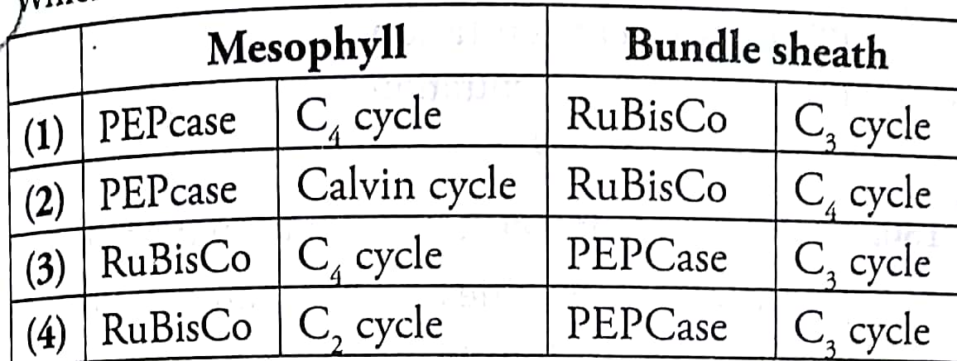

1. Select the correct statement regarding the first stable product formed in Hatch and Slack pathway in C4 plants

1. Oxaloacetate is formed by carboxylation of phosphoenol pyruvate (PEP) in the bundle sheath cells.

2. Oxaloacetate is formed by carboxylation of phosphoenol pyruvate (PEP) in the mesophyll cells

3. Phosphoglyceric acid is formed in the mesophyll cells.

4. Phosphoglyceric acid is formed in the bundle sheath cells

1. C4 plants are more sensitive to low temperature than C3 because

1. They have chloroplast dimorphism

2. Regeneration of RuBP in bundle sheath cells is affected at low temperature.

3. Primary fixation of carbon is inhibited as PEPcase becomes less active.

4. PEP regeneration is decreased as PEP synthetase is sensitive to low temperature.

1. Internal factors affecting photosynthesis are

1. Number and size of leaf. 2. Age of leaf and orientation

3. Internal CO2 concentration and amount of chlorophyll

4. All of these

1. Which of the following is wrongly matched?

1. Sorghum - Kranz anatomy 2. Blackman - Law of limiting factors

3. Photorespiration- C3 plants 4. PS II – P700

1. Fill in the correct numeric responses in the following statements

a. Light saturation occurs at_ (i) __ percent of the full sunlight

b. Increase in concentration of CO2 up to- (ii) percent can cause an increase in CO2 fixation rates

c. C3 plants show saturation at about- (iii) , while C3 responds to increased CO2 concentration and saturation is seen only beyond_(iv)

1. (i)-25; (ii) - 0.50; (ii) -450 ppm; (iv)-360 ppm

2. (i) 10;(ii) 0.05; iii) - 360 ppm; (iv) -450 pmm

3. (i)-2; (ii)-0.05; (iii)-450 ppm; (iv) -360 ppm

4. (i)-1; (ii)-1.0; (iii)-180 ppm; (iv)-650 ppm

1. Select the incorrect statement from the following

1. At high intensities, both C3 and C4 plants shows increase in rate of photosynthesis by increasing CO2 concentration.

2. C4 plants show saturation at 360 ppm.

3. C3 plants show saturation beyond 450 ppm.

4. Productivity of tomatoes and bell pepper cannot be increased by enriching environment by CO2

1. If a plant is kept in 300 ppm CO2 concentration, what will happen to it?

1. Plant will die soon. 2. Plant will grow but will not die.

3. Plant will show normal photosynthesis. 4. Respiration will be greatly decreased

1. At higher light intensities gradually photosynthesis rate does not show further increase, why?

1. Higher light intensity activate more chlorophylls

2. Higher light intensity causes more transpiration

3. No need of more sugar formation 4. Other factors become limiting

1. Under water stress, the rate of photosynthesis declines because of

1. Stomatal closure leading to decrease in CO, supply

2. Reduced water potential that decreases leaf surface areas for photosynthesis

3. Both 1 and 2 4. Turgidity of leaf

1. Warburg effect refers to

1. Decreased photosynthetic rate at very high O2 concentration.

2. Increased photosynthetic rate at very high O2 concentration.

3. Decreased photosynthetic rate at very low O2 concentration.

4. Increased photosynthetic rate at very low O2 concentration

1. Generally atmospheric CO2 is not limiting for hydrophytes. The reason for this is

1. Mesophytes plants fix H2S in their photosynthesis.

2. These plants obtain CO2 from water in the form of НСО

3. Glucose is not required for their respiration. 4. All of these

1. Anoxygenic photosynthesis is a characteristic of

1. Rhodospirillum 2. Spirogyra. 3. Chlamydomonas 4. Ulva

1. The process used in conversion of pyruvate to acetyl CoA is

1. Oxidative dehydration 2. Oxidative decarboxylation

3. Oxidative phosphorylation 4. Oxidative dehydrogenation

1. Which of the following is incorrect about Krebs cycle?

1. It occurs in mitochondria 2. It starts with two carbon compound Acetyl CoA

3. It is also called TCA cycle 4. It is common for aerobic and anaerobic respiration

1. Which of the following features about Krebs cycle is/are correct?

1. It is stepwise carboxylation of Acetyl CoA

2. NADH, FADH2 and GTP are produced

3. Citrate is the first product of condensation of OAA and Pyruvate 4. All are correct

1. Which of the following is/are the processes of decarboxylation?

1. Conversion of Pyruvate in to Acetyl CoA

2. Conversion of Oxalosuccinate to α-ketoglutarate

3. Conversion of α-ketoglutarate to Succinyl CoA 4. All these

1. The only 5-Carbon compound in TCA cycle is

1. Succinyl CoA 2. Acetyl CoA 3. Oxaloacetate 4. α-Ketogluterate

1. The reactions of the TCA cycle occur in

1. Ribosomes 2. Grana 3. Mitochondria 4. ER

1. Number of NADH produced during Krebs cycle per glucose molecule is

1. 6 molecules 2. 2 molecules 3. 10 molecules 4. 8 molecules

1. Product of reduction of Succinate into fumerate is

1. NADPH2 2. NADH2 3. FMN 4. FADH2

1. Krebs cycle starts with the formation of six carbon compound by a reaction between

1. Malic acid and acetyl coenzyme 2. Oxalocetic acid and acetyl coenzyme

3. Succinic acid and pyruvic acid 4. Fumaric acid and pyruvic acid

1. All enzymes of TCA cycle are located in the mitochondrial matrix except one which is located in the inner mitochondrial membrane in eukaryotes and this enzyme is

1. Isocitrate dehydrogenase 2. Malate dehydrogenase

3. Succinic dehydrogenase 4. Lactate dehydrogenase

1. Which one is not correct about Krebs cycle?

1. It is also called citric acid cycle

2. The intermediate compound which links glycolysis with Krebs cycle is malic acid

3. It occurs in mitochondria 4. It starts with six carbon compound

1. GTP is formed during the conversion of

1. α- ketoglutaric acid into succinyl CoA 2. Succinyl CoA into succinic acid

3. Succinic acid into fumaric acid 4. Fumaric acid into malic acid

1. Most enzyme that take part in ‘Krebs cycle’ are located in

1. Mitochondrial matrix 2. Cytoplasm

3. Inner mitochondria membrane 4. Plasma membrane

1. The complete breakdown of glucose requires which of the following pathway?

1. Glycolysis 2. Krebs cycle 3. ETS 4. All these

1. The number of carbon present in isocitric acid, fumaric acid, pyruvic acid respectively

1. 6, 4, 3 2. 3, 4, 6 3. 4, 3, 6 4. 6, 3, 4

1. FAD acts as an electron acceptor is between

1. Fumaric acid and malic acid 2. Succinic and fumaric acid

3. Malic acid and oxaloacetic acid 4. Citric and isocitric acid

1. Cytochrome c oxidase consists of

1. Cyt b and Cyt c1 2. Cyt a and Cyt a3 3. Cyt b and Cyt C1 4. Cyt b6 and Cyt f

1. Mobile electron carriers present in the ETC are

1. Cyt a and Cyt a3 2. UQ and Cyt c 3. Cyt a3 and UQ 4. UQ and Cyt b

1. Ultimate electron acceptor in aerobic respiration is

1. Oxygen 2. Water 3. Glucose 4. Acetyl CoA

1. Which of the following does not function as an electron carrier?

1. Coenzyme - Q 2. Cytochrome - c 3. Cytochrome - a 4. H2O

1. During aerobic respiration, net ATP molecules produced by substrate level phosphorylation in yeast cells per glucose molecules is

1. 4 2. 8 3. 6 4. 2

1. Difference between photophosphorylation (PP) and oxidative phosphorylation (OP) is

1. In PP, O2 is liberated while in OP, O2 is used

2. In PP, ATP is formed while in Op, ADP is formed

3. Both cannot take place in light

4. PP can occur in green leaves while OP cannot

1. Respiratory quotient is represented by

1.  2.  3.  4. 

1. Total amount of energy per glucose molecules is

1. 38 ATP 2. 36 ATP 3. 8 ATP 4. 2 ATP

1. Total ATP production during EMP pathway is

1. 24 ATP molecules 2. 8 ATP molecule 38 ATP molecules 4. 6 ATP molecule

1. If the volume of CO2 liberated during the respiration is equal to O2 absorbed, then the substrate used will be

1. Carbohydrate 2. Protein 3. Organic acid 4. Fats

1. The amount of energy received from one ATP molecule is

1. 7.3 Kcal 2. 76 Kcal 3. 760 Kcal 4. 1000 Kcal

1. Pasteur effect refers to

1. Decreased respiration with increased O2

2. Release of CO2 during respiration

3. Shifting from anaerobic condition to aerobic condition in facultative anaerobes

4. Increased consumption of carbohydrates in the presence of O2

1. Reason for using germinating seeds in Ganong’s respiroscope experiment is

1. Germinating seed only release heat energy which can be identified in this experiment

2. Rate of respiration is high in germinating seeds and hence CO2 release can be determined

3. Both 1 and 2

4. Evolution of O2 during respiration can be determined

1. RQ for organic acids is

1. Zero 2. 1.0 3. Less than 1.0 4. More than 1.0

1. R.Q of sprouting potato tubers will be

1. > 1 2. 0 3. 1 4. < 1

1. Which of the following is site of respiration in bacteria?

1. Episome 2. Mesosome 3. Polysome 4. Ribosome

1. Refrigeration/ cold storage is advantageous for storage of fruits because

1. Rate of respiration in plants decreases with temperature

2. No microorganisms can grow in cold temperature

3. It is safe to store plant materials in refrigeration 4. Both 1 and 2

1. Anaerobic respiration in the muscles does not produce

1. Lactic acid 2. Energy 3. Carbon dioxide 4.both 1 and 2

1. When the bread is baked, it becomes light and spongy, because

1. The evaporation of alcohol from fermented flour

2. The evolution of CO2 from the dough 3. The presence of yeast

4. The production of ethyl alcohol and CO2

1. The number of glucose molecules required to produce 38 ATP molecules under anaerobic condition by a yeast cell is

1. 2 2. 4 3. 19 4. 38

1. Production of alcohol by yeast fermentation is

1. Aerobic Process 2. Light dependent process

3. Anaerobic process 4. Both 2 and 3

1. Rate of respiration depends upon which of the following factors except

1. CO2 2. Humidity 3. O2 4. Glucose

1. The enzyme involved during lactic acid fermentation in *Lactobacillus* is

1. Zymase 2. Lactic dehydrogenase

3. Lactase 4. Maltase

1. Flooding cultivation is followed or paddy plants because

1. They have efficient root system in absorption of oxygen from deep soil

2. The root system shows anaerobic respiration during flooding conditions

3. Root system need strict anaerobic conditions

4. None of these

**Topic: Transport in plants, Mineral Nutrition and Plant growth and Development**

**Unit: B-06**

**ANSWER KEY**

|  |  |  |  |  |  |  |  |  |  |
| --- | --- | --- | --- | --- | --- | --- | --- | --- | --- |
| **Q. No.** | **Ans.** | **Q. No.** | **Ans.** | **Q. No.** | **Ans.** | **Q. No.** | **Ans.** | **Q. No.** | **Ans.** |
| 1 | **2** | 2 | **4** | 3 | **4** | 4 | **4** | 5 | **3** |
| 6 | **1** | 7 | **4** | 8 | **2** | 9 | **4** | 10 | **4** |
| 11 | **3** | 12 | **2** | 13 | **4** | 14 | **4** | 15 | **3** |
| 16 | **4** | 17 | **1** | 18 | **2** | 19 | **4** | 20 | **1** |
| 21 | **1** | 22 | **4** | 23 | **4** | 24 | **4** | 25 | **1** |
| 26 | **4** | 27 | **2** | 28 | **3** | 29 | **1** | 30 | **2** |
| 31 | **3** | 32 | **2** | 33 | **2** | 34 | **3** | 35 | **3** |
| 36 | **2** | 37 | **4** | 38 | **1** | 39 | **2** | 40 | **4** |
| 41 | **4** | 42 | **4** | 43 | **2** | 44 | **4** | 45 | **3** |
| 46 | **4** | 47 | **3** | 48 | **1** | 49 | **2** | 50 | **1** |
| 51 | **2** | 52 | **4** | 53 | **2** | 54 | **4** | 55 | **4** |
| 56 | **3** | 57 | **1** | 58 | **4** | 59 | **2** | 60 | **3** |
| 61 | **2** | 62 | **2** | 63 | **1** | 64 | **4** | 62 | **1** |
| 66 | **2** | 67 | **2** | 68 | **2** | 69 | **1** | 70 | **4** |
| 71 | **1** | 72 | **1** | 73 | **3** | 74 | **1** | 75 | **2** |
| 76 | **1** | 77 | **1** | 78 | **3** | 79 | **2** | 80 | **4** |
| 81 | **3** | 82 | **2** | 83 | **4** | 84 | **3** | 85 | **2** |
| 86 | **3** | 87 | **3** | 88 | **2** | 89 | **2** | 90 | **2** |